Francesco SANTAGIUSTINA Quantum Information and computing

Lab. report 2 : quantum tomography

**Experimental setup scheme:**

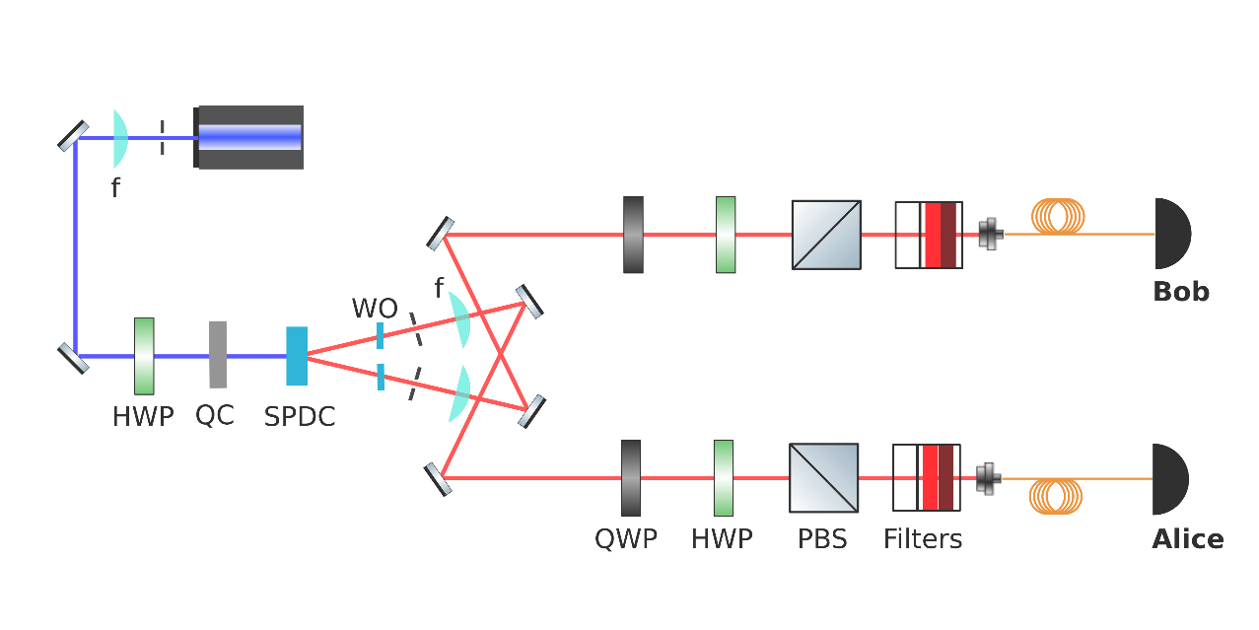

Figure 1: Scheme of our apparatus, please note the following elements: lenses (f), half-wave plates (HWP), quarter-wave plates (QWP). polarizing beam splitters (PBS), quartz crystal (QC) and the spontaneous parametric down-conversion crystal (SPDC). Alice and Bob represent the two detectors implemented by single-photon avalanche diodes (SPAD).

**Experiment description:**

In this laboratory experience we aim to characterize a quantum state that we repeatedly produce and measure. Our system is composed of a pair of photons generated by down-conversion, and whose polarization state represents two qubits. Apart from a few details which will be specified, the experiment and analysis we performed are those described in detail by James, Kwiat, Munro and White in their paper “Measurement of qubits” [[1]], so please refer to it for a comprehensive explanation.

To fully characterize the state of a quantum system (that is defining its density matrix) one must perform repeatedly a set of measurements on identically prepared copies of the quantum system. Each measurement is performed many times on newly prepared copies in order to infer the probability of each outcome from the distribution of realizations. These data are then combined with Born’s rule to obtain an estimate of the density matrix. When we think about the uncertainty principle it is obvious that only one measurement (even if performed many times) isn’t sufficient to characterize a general (previously unknown) qubit state. We actually need to perform a so called tomographically complete set of measurements. Such set must be composed of 4 measurements for a single qubit and it increases exponentially with the number of qubits composing the system, so we need 42=16 different measurements to be performed. This condition result from the necessity of being able to span the whole system state Hilbert space with the measurement operators. As we are dealing with light polarization, the measurement of different observables results into projecting each photon along specific orthogonal polarizations. This is equivalently achieved in our experimental setup by always projecting onto the horizontal/vertical polarizations thanks to a polarizing beam splitter (PBS) after having performed an arbitrary rotation (in the Bloch sphere) of the incoming photon by letting it pass through a quarter-wave plate (QWP) and a half-wave plate (HWP) whose fast axis angles are set accordingly. We note that while in the article the photon counter detector counts the photons collapsed into vertical state, in our setting it counts the photons collapsed into horizontal polarization state (obviously this is only a matter of definition and once the due compensations are done, the results are equivalent). Globally the projection of the generated photon will thus be made onto the polarization state which, after the rotation due to the QWP and HWP, becomes vertical or horizontal (the latter is counted, the former discarded). This states from now on will be called the tomographic states and are reported in *Figure 1*. The given angles don’t necessarily coincide with those actually shown by the QWP and HWP goniometers because the calibration offset need to be determined (we did this by fitting our measures to Malus law) and added to them (13° for HWPa, 64° for HWPb, 19° for QWPa and 51.5 for QWPb in our particular case).

Figure 1: Each line corresponds to a measurement defined by its tomographic states (for photon A and B) and corresponding angles of the fast axis for the Half-Wave Plate and Quarter-Wave Plate (before detectors a and b). Coincidence counts for the two prepared Bell states are shown next to each measurement setting.

In order to temporally filter noise from external source we will only count the number of coincident arrivals to the two photodetectors in a fixed time window (of a few seconds). The optical path being almost equal in length, photons should arrive almost at the same time (or with a fixed delay of which we can get rid of in postprocessing). Wave-length and directional filters also contribute to avoid counting irrelevant photons.

**Results and data analysis:**

In theory this set of coincidence counts can be univocally mapped into a density matrix by a closed form formula (see formula 3.14 of [1]). Unfortunately, due to noise in experimental results, the resulting matrix may not be a proper density matrix representing a physical state: this matrix is indeed Hermitian and of unitary trace by construction but may fail to be positive semidefinite. I implemented anyway this first procedure in MATLAB, obtaining the following proposed density matrix:

$\hat{ρ}=\left[\begin{matrix}0.4926 & 0.0181-0.0463i & -0.0128+0.0168i & -0.3831+0.0742i \\ 0.0181+0.0463i & 0.0050 & 0.0493+0.0172i & -0.0379-0.0269i \\ -0.0128-0.0168i & 0.0493-0.0172i & 0.0075 & -0.0776+0.0524i \\ -0.3831-0.0742i & -0.0379+0.0269i & -0.0776-0.0524i & 0.4949\end{matrix}\right]$

whose eigenvalues: $\left\{ 0.8939, 0.1480, 0.0214, -0.0632 \right\}$ are not all non-negative, as we feared.

Paper [1] suggest to overcome this problem by finding the positive semidefinite matrix which is most likely given the counts we have found. One first need to generate a formula returning only physical density matrices by construction, this density matrix will be a function of 16 real auxiliary variables *ti* (this set of variables is thus bijectively linked to proper density matrices satisfying normalization, hermicity and positivity). Then, by modelling noise in coincidence counts as gaussian, one is able to define the likelihood function that needs to be maximized, or equivalently the log-likelihood to be minimized. This can be done by standard optimization techniques: differently from the paper I used the MATLAB function fminsearch but, by applying it to the counts given in the paper I obtain the same results as them up to a high level of precision. I also started, as initial point of the optimization, from the *ti* obtained by taking the real part of the result of the inverse formula for *ti* applied to the tomographic density matrix $\hat{ρ}$ previously found. In this way I obtained the physical density matrix:

$$ρ_{physical}=\left[\begin{matrix}0.4952 & 0.0261-0.0327i & 0.0200+0.0206i & -0.4209+0.0329i \\ 0.0261+0.0327i & 0.0051 & 0.0003+0.0056i & -0.0351-0.0355i \\ 0.0200-0.0206i & 0.0003-0.0056i & 0.0092 & -0.0385+0.0371i \\ -0.4209-0.0329i & -0.0351+0.0355i & -0.0385-0.0371i & 0.4905\end{matrix}\right]$$

whose eigenvalues: $\left\{ 0.000, 0.009, 0.0757, 0.9233 \right\}$ are all non-negative, as we wanted. The greatest eigenvalue $0.9233$ is associated to the eigenvector $\left(\begin{matrix}-0.70 + 0.05i \\ -0.05 - 0.05i \\ -0.04 + 0.05i \\ 0.7032 \end{matrix}\right)$ which is close to the first state that we desired to prepare: ${|Φ}^{-}> =\frac{1}{\sqrt{2}}(|HH>-|VV>)=\frac{1}{\sqrt{2}}(|VV>-|HH>)$.

We can compute the fidelity of our preparation as the probability that it will pass a test to identify as the desired state, as the desired state is pure we can say that: $F={<Φ}^{-}|{ρ_{physical}|Φ}^{-}>=0.9137$.

By Peres criterion we can show that this density matrix corresponds to an entangled state: the partial transpose with respect to B of the joint density matrix has: $\left\{ -0.4236, 0.4279, 0.4953, 0.5004\right\}$ as eigenvalues, and so do not correspond to a physical state, which implies (for 2x2 systems) that photons A and B are entangled. Many quantities of interest could be computed from the density matrix, for instance we find that the von Neuman entropy is $S=0.3977$ for the joint system while the entanglement of formation is $E_{f}=0.7786$ (both computed using logarithm in base 2 giving results in bits and ebits).

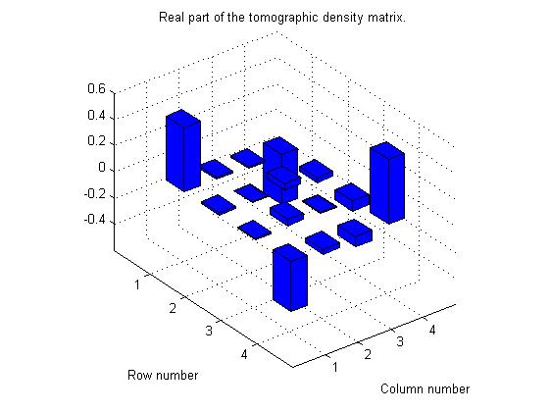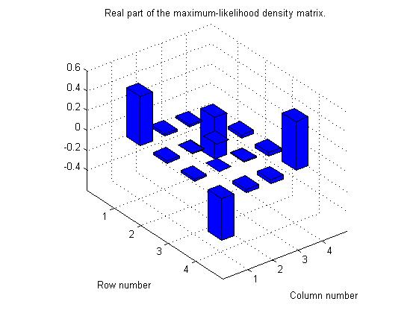

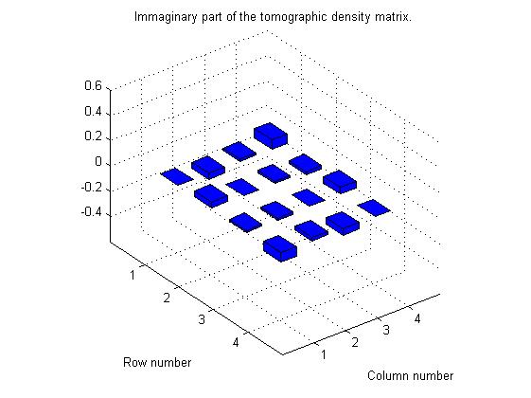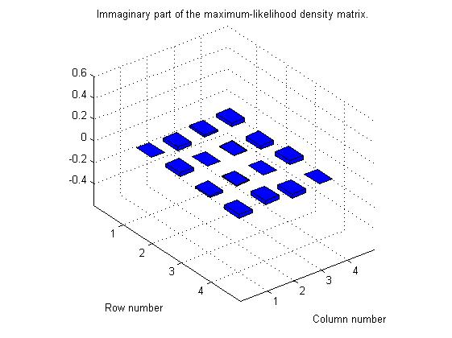

Successively we tried to prepare a different state: ${|Φ}^{+}> =\frac{1}{\sqrt{2}}(|HH>+|VV>)$ and repeated the whole density matrix identification process. Due to time constraints we actually performed new counts for measurement associated to the tomographic states $|DD>$ and $|RL>$ because theoretically only there the different phase shift should result in different results as it avoids destructive interference, and to the state $|HH>$ whose counts have been used to determine the scaling factor that needed to be applied to all the remaining coincidence counts in order to represent the variation of link-budget due to the involuntary changes made to the experimental setup. In this case we obtained the following proposed density matrix from the tomographic approach:

$$\hat{ρ}=\left[\begin{matrix}0.4926 & 0.0181-0.0463i & -0.0128+0.0168i & 0.5827+0.0742i \\ 0.0181+0.0463i & 0.0050 & 0.0493+0.0172i & -0.0379-0.0269i \\ -0.0128-0.0168i & 0.0493-0.0172i & 0.0075 & -0.0776+0.0524i \\ 0.5827-0.0742i & -0.0379+0.0269i & -0.0776-0.0524i & 0.4949\end{matrix}\right]$$

whose eigenvalues: $\left\{ -0.1606, -0.0294, 0.1039, 1.0861 \right\}$ are not all non-negative, resulting in a non-physical density matrix. As earlier we apply the maximum likelihood approach, obtaining:

$$ρ_{physical}=\left[\begin{matrix}0.5333 & 0.0094-0.0150i & -0.0266-0.0142i & 0.4836+0.0382i \\ 0.0094+0.0150i & 0.0051 & 0.0009+0.0040i & 0.0019 +0.0092i \\ -0.0266+0.0142i & 0.0009-0.0040i & 0.0076 & -0.0321+0.0161i \\ 0.4836-0.0382i & 0.0019-0.092i & -0.0321-0.0161i & 0.4540\end{matrix}\right]$$

whose eigenvalues: $\left\{ 0.000, 0.000, 0.0170, 0.9830 \right\}$ are all non-negative and the greatest one is associated to the eigenvector $\left(\begin{matrix}0.73 + 0.06i \\ 0.00 + 0.02i \\ -0.04 + 0.02i \\ 0.6769 \end{matrix}\right)$ which is close to the state we desired to prepare. The fidelity of our preparation to the desired state is $F=0.9772$ in this case, better than previously.

Again, Peres criterion show that the two photons are entangled. The von Neuman entropy is $S=0.1247 bits$ for the joint system while the entanglement of formation is $E_{f}=0.9503 ebits$ which is very close to the value of 1 ebit for a perfectly prepared Bell state.

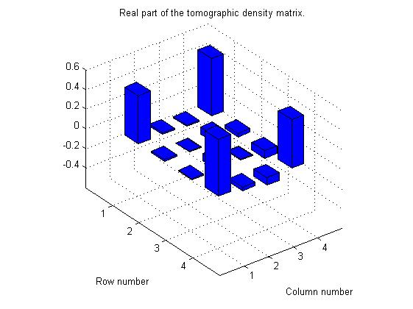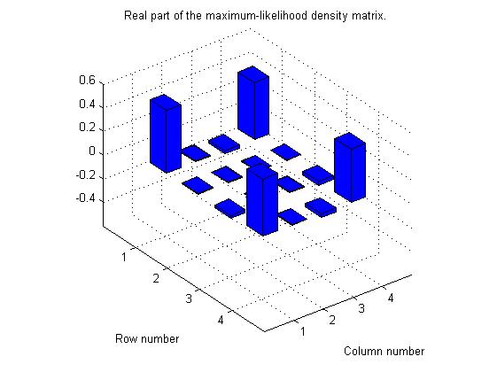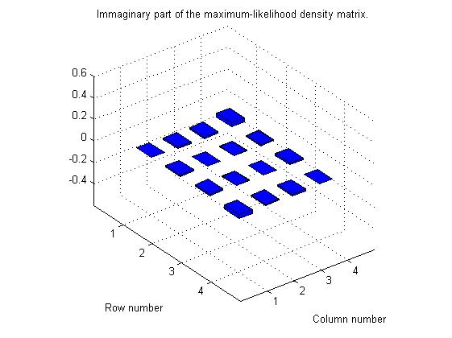

**Additional notes:**

The MATLAB algorithm used to obtain all the previous results follow the mathematical formulation of [1] with some slight adaptations and can be found in the folder “Lab2 MATLAB code”, the main file that need to be run is “LAB2.m”, it is essential that the main file is kept together with all its subroutines contained in the other “*.m” files and the experimental data in “Tomo.xls”.

1. [1] James, Daniel F. V., Paul G. Kwiat, William J. Munro, and Andrew G. White. “Measurement of qubits.” *Physical Review A* 64, no. 5 (October 16, 2001). doi.org/10.1103/PhysRevA.64.052312.